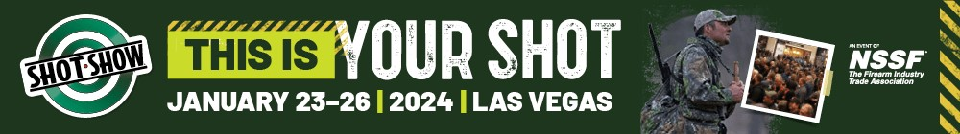
EAC IMMEDIATE ACTION REQUIRED

You may receive wristbands and enter the hall upon completion and acceptance of the documents below.

EAC AGREEMENT:
We have a contract to work as an Exhibitor-Appointed Contractor for __________________________________ in booth _____________ at the 2022 SHOT Show. We have read the EAC Rules in the Exhibitor Resource Center on-line and agree to abide by all Show guidelines, rules, display regulations, requirements and union jurisdictions of the SHOT Show. I have checked the service (s) to be performed:

[ ] Audio/Visual & Computers
[ ] Display Rental
[ ] Exhibit Installation & Dismantle
[ ] Exhibit Supervision
[ ] Floral
[ ] Furnishings
[ ] Hostess/Models
[ ] Personnel, Temporary
[ ] Photography/Video
[ ] Signs
[ ] Other (Please List):___________________________

Exhibitor ___________________________________________ Booth #____________

Exhibitor Contact ______________________________________Cell ____________________

EAC ______________________________________________________________

On-Site Supervisor ______________________________________Cell_____________________

Agreed to by: ______________________________________Date ___________________

CERTIFICATE OF INSURANCE REQUIRED: INSURANCE: LIABILITY
Certificate must have this language:
- EAC must obtain and maintain during the term of this Agreement a policy of comprehensive general liability insurance which consists of $2,000,000 combined single-limit bodily injury and broad-form property damage, including broad-form contractual liability which names National Shooting Sports Foundation (NSSF), ConvExx, Freeman, Eastside Convention Center, LLC. dba as Caesars Forum, Caesars Entertainment, Expo & Convention Center, Inc, (“ECC”), Venetian Casino Resort, LLC (“VCR”), Grand Canal Shoppes II (“GCS”), The Shoppes at the Palazzo, LLC (“SATP), Phase II Mall Subsidiary, LLC (“PIIMS”), and its parent subsidiary, and each of the directors, officers, agents, shareholders and employees of each as additional insured with respect to any written contract they may have with the named insured in or about the property of VCR, SECC, GCS and SATP.
- EAC agrees that their insurance coverage will be of a “Best A” rating or better, and be primary and non-contributory to any other insurance coverage, and provides a Waiver of Subrogation in favor of National Shooting Sports Foundation (NSSF), ConvExx, Freeman, Eastside Convention Center, LLC. dba as Caesars Forum, Sands Expo & Convention Center and Venetian Casino Resort, L.L.C.

INSURANCE: WORKERS COMPENSATION
- EAC warrants that it has in full-force at all times during the term of this Agreement a policy of workers’ compensation insurance which meets all federal and state requirements as evidenced by a certificate of insurance (COI).
- The insurance required by this Agreement shall contain a provision which requires notification to Show Management 30 days in advance of any cancellation, non-renewal or material change in the policy terms.
Email documents to Kathryn Rae at krae@convexx.com

